IT24100184

Srinuka D.G.U

PS-Lab – 10

Q1-

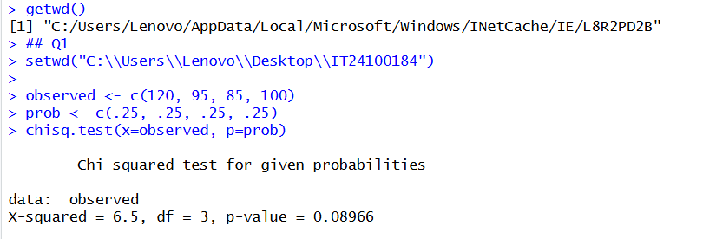

Q2-

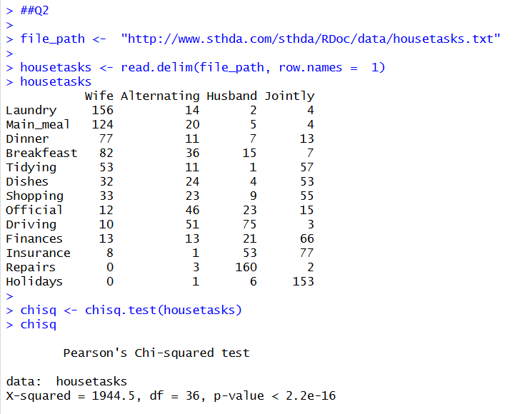

Q3-

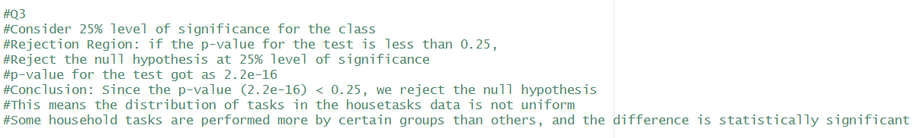

Q3

Consider 25% level of significance for the class

Rejection Region: if the p-value for the test is less than 0.25,

Reject the null hypothesis at 25% level of significance

p-value for the test got as 2.2e-16

Conclusion: Since the p-value (2.2e-16) < 0.25, we reject the null hypothesis

This means the distribution of tasks in the housetasks data is not uniform

Some household tasks are performed more by certain groups than others, and the difference is statistically significant